Inspection Audit Reporting Module
A Quick Guide

1. Inspection Reports

These reports will display the data related to the Inspection Reporting Module
To Navigate to this module login into BI instance using the below url.
http://192.168.166.203:9704/analytics/saw.dll?bieehome&startPage=1

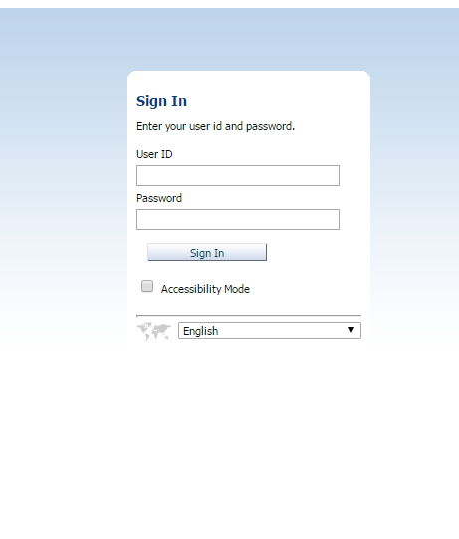

Enter the below Credentials
User ID : Operations
Password : welcome1

Once Logged in then navigate to the dashboards and select Navigation Audit Dashboard

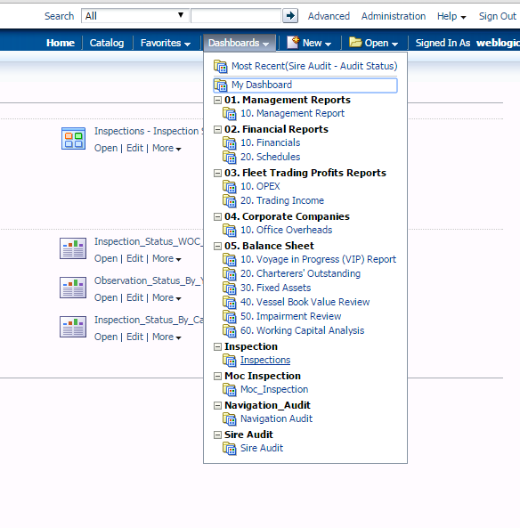

- Once logged in then click on the URL to navigate to the required report.
    - There are few Parameters for the each report. They are
        - Category : Inspection Category
        - Year : Select the particular year for which the data to be displayed.
        - Fleet : Select the Fleet type required.

As shown below:

